

***Juniper Contrail vRouter DPDK***

***with AMD EPYC Processor***

***Performance Report - Release R2003***

Authors:

Przemysław Grygiel [pgrygiel@juniper.net](mailto:pgrygiel@juniper.net),

Damian Szeluga [dszeluga@juniper.net](mailto:dszeluga@juniper.net),

Reviewer:

Dilip Sundarraj [dsundarraj@juniper.net](mailto:dsundarraj@juniper.net)

***Revision History***

|  |  |  |
| --- | --- | --- |
| Date | Revision | Comment |
| May 2020 | 1.0 | Initial document |
|  |  |  |

***Contents***

***Audience and Purpose*** ***4***

***Hardware Specifications*** ***4***

*General CPU allocation* *5*

*Hypervisor configuration description* *5*

***Test setup*** ***6***

***About PROX and Rapid*** ***7***

*Prox VMs tuning description (compute-B)* *7*

***Performance Test*** ***9***

*Configuration of vRouter on compute-B (DUT):* *9*

*CPU allocation (Full-CPU partitioning scheme) on compute-B:* *9*

*Traffic pattern* *9*

*Total Gpbs for various number of allocated cores* *10*

*Total Mpps [TX+RX] various core allocation* *11*

*Mpps/core for 64B various core allocation* *12*

*Average latency* *13*

*Mellanox ConnectX-5 configuration* *14*

*Detailed data* *15*

***Appendix*** ***16***

*Guide how to run testing framework* *16*

*Configure high performance Contrail Cloud computes* *16*

*Configure high performance Contrail Networking on computes with TripleO heat templates* *19*

***References*** ***23***

# ***Audience and Purpose***

The primary audience for this test report are system engineers, sales engineers and solution architects looking at the dataplane of Contrail Networking. This report presents information about the packet processing performance for AMD EPYC 7742 64-Core Processor on the specified testbed.

The purpose of this report is to provide guidance in terms of base line numbers that one can expect if they follow the same set of steps on a similar testbed with similar hardware configuration. This will help guide architects and engineers who are evaluating and implementing dataplane solutions and can assist in achieving optimal system performance.

# ***Hardware Specifications***

|  |  |
| --- | --- |
| Model name | AMD EPYC 7742 64-Core Processor |
| CPUs | 128 |
| Sockets | 2 |
| Cores per Socket | 64 |
| Threads per core | 2 |
| NUMA 0 CPU list | 0-63,128-191 |
| NUMA 1 CPU list | 64-127,192-255 |
| NICs | 2 x 100Gbps Mellanox ConnectX-5 MT28800 |

## 

## General CPU allocation

|  |  |
| --- | --- |
|  | Core list |
| Nova cores allocation for VMs | 1-31,48-63 (only physical cores on NUMA 0) |
| Host OS | 0,1,128,129,64,65,192,193 |
| vRouter | 32,33,34,35,36,37,38,39,160,161,162,163,164,165,166,167 (NUMA 0 with siblings) |

## Hypervisor configuration description

|  |
| --- |
| OS version  cat /etc/os-release  NAME="Red Hat Enterprise Linux Server"  VERSION="7.7 (Maipo)"  Kernel isolcpu and huge pages  # cat /proc/cmdline  cat /proc/cmdline  BOOT_IMAGE=/boot/vmlinuz-3.10.0-1062.12.1.el7.x86_64 root=UUID=228c59ea-82f0-4ee8-9d03-5620e5f0fafb ro console=tty0 console=ttyS0,115200n8 crashkernel=auto rhgb quiet **isolcpus=2-63,67-127,130-191,195-255** amd_iommu=on iommu=pt intel_iommu=on default_hugepagesz=1GB **hugepagesz=1G hugepages=128** hugepagesz=2M hugepages=8192 skew_tick=1 nohz=on nohz_full=2-63,67-127,130-191,195-255 rcu_nocbs=2-63,67-127,130-191,195-255 tuned.non_isolcpus=00000007,00000000,00000003,00000000,00000007,00000000,00000003 intel_pstate=disable nosoftlockup  Nova vcpu pinning  grep ^vcpu /var/lib/config-data/puppet-generated/nova_libvirt/etc/nova/nova.conf  vcpu_pin_set=**"2-31,48-63"**  Tuned cpu-partitioning profile configuration  grep ^isolated_cores /etc/tuned/cpu-partitioning-variables.conf  isolated_cores=**2-63,67-127,130-191,195-255**  vRouter forwarding cores allocation  # grep ^CPU /etc/sysconfig/network-scripts/ifcfg-vhost0  CPU_LIST=32,33,34,35,36,37,38,39,160,161,162,163,164,165,166,167  NIC card  lspci | grep ConnectX-5  a1:00.0 Ethernet controller: Mellanox Technologies MT28800 Family [ConnectX-5 Ex]  a1:00.1 Ethernet controller: Mellanox Technologies MT28800 Family [ConnectX-5 Ex] |

# ***Test setup***

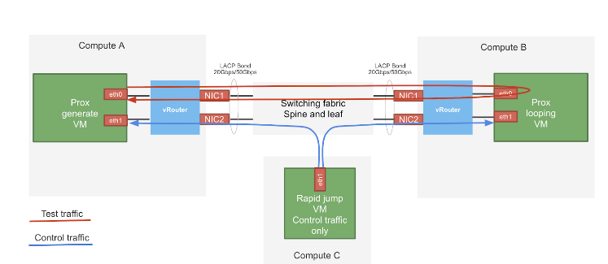

The test setup consists of three compute nodes with the above mentioned hardware specification. The device under test (DUT) is compute-B in the above setup where the vRouter is running. The vRouter is hosting a PROX VM which just loops traffic on the same interface. The traffic generator is also a PROX VM hosted by vRouter in compute-A. There is a third VM called Control traffic VM which is running in compute-C. The purpose of this VM is to control the traffic generator (start, stop, pause etc.) and also to collect statistics. In order to saturate the DUT, the traffic generator VM and compute are allocated much more resources than the DUT. The vRouter itself is running on a bonded interface in 802.3ad LACP mode.

By default on Prox generate and Prox looping VMs the multiqueue is enabled with a number of queues appropriate to vRouter queues. Enabling the multiqueue means enabling it on the openstack and VM (Prox) level.

# 

# ***About PROX and Rapid***

Prox is an OPNFV project application built on top of DPDK which allows to create flexible software architectures through small and readable configuration files. One of the ways PROX can be used is as a traffic generator for performance investigations. Rapid is a wrapper on PROX to simplify the configuration of PROX even further.

Rapid github repository:

<https://github.com/opnfv/samplevnf/blob/master/VNFs/DPPD-PROX/helper-scripts/rapid/README>

Heat templates to deploy Rapid

<https://github.com/damjanek/dpdk-prox-contrail>

## Prox VMs tuning description (compute-B)

The Prox VMs are also tuned using kernel isolcpu and tuned profile and have enabled multiqueue

|  |
| --- |
| OS version  # cat /etc/os-release  NAME="CentOS Linux"  VERSION="7 (Core)"  Kernel isolcpu  # cat /proc/cmdline  BOOT_IMAGE=/boot/vmlinuz-3.10.0-1062.12.1.el7.x86_64 root=UUID=3ef2b806-efd7-4eef-aaa2-2584909365ff ro console=tty0 console=ttyS0,115200n8 crashkernel=auto console=ttyS0,115200 LANG=en_US.UTF-8 **isolcpus=1-17** intel_pstate=disable nosoftlockup skew_tick=1 nohz=on nohz_full=1-17 rcu_nocbs=1-17  Tuned realtime-virtual-guest-variables profile configuration  grep ^isolated_cores /etc/tuned/realtime-virtual-guest-variables.conf  isolated_cores=1-17  Multiqueue enabled in Image  openstack image show rapidVM-1908 -c properties -f value  direct_url='rbd://27ef521a-743a-11ea-b2f9-5254001643f5/images/56aac0c7-dc10-4756-af2d-c0f115735561/snap', **hw_vif_multiqueue_enabled='true'**, locations='[{u'url': u'rbd://27ef521a-743a-11ea-b2f9-5254001643f5/images/56aac0c7-dc10-4756-af2d-c0f115735561/snap', u'metadata': {}}]'  Multiqueue enabled in Prox (CPU allocation for looping VM compute-B)  **Core 2: RX port 0 (queue 0) ==> TX port 0 (queue 0)**  **Core 3: RX port 0 (queue 1) ==> TX port 0 (queue 1)**  **Core 4: RX port 0 (queue 2) ==> TX port 0 (queue 2)**  **Core 5: RX port 0 (queue 3) ==> TX port 0 (queue 3)**  **Core 6: RX port 0 (queue 4) ==> TX port 0 (queue 4)**  **Core 7: RX port 0 (queue 5) ==> TX port 0 (queue 5)**  **Core 8: RX port 0 (queue 6) ==> TX port 0 (queue 6)**  **Core 9: RX port 0 (queue 7) ==> TX port 0 (queue 7)**  VM flavor properties  openstack flavor show ii-stack3-swap -c properties -f value  **hw:cpu_policy='dedicated', hw:mem_page_size='large'** |

# 

# 

# Performance Test

## Configuration of vRouter on compute-B (DUT):

|  |  |
| --- | --- |
| Operating System | RedHat 7.7 |
| Number of Forwarding Cores | 2-8 (Physical) + 2-8 (Siblings) |
| Drop Rate | 0.001% |
| Bond | 2 x 100G (802.3ad LACP) with L3/L4 hash (Mellanox ConnectX-5) |
| Hugepages | 1G |
| NUMA allocation | vRouter, NIC and VM on the same socket (NUMA 0) |

## CPU allocation (Full-CPU partitioning scheme) on compute-B:

|  |  |
| --- | --- |
| vRouter forwarding cores | 32,33,34,35,36,37,38,39,160,161,162,163,164,165,166,167 |
| Service cores | 40 |
| Control cores | 40 |
| Nova (VM) cores [VM core: HV core] | 0: 16, 1: 11, 2: 6, 3: 20, 4: 7, 5: 23, 6: 53, 7: 51, 8: 29, 9: 61, 0: 21, 1: 59, 2: 54, 3: 5, 4: 28, 5: 4, 6: 13, 7: 19 |
| Host OS cores | 0,1,128,129,64,65,192,193 |
| Kernel isolcpus and tuned isolcpu list | 2-63,67-127,130-191,195-255 |

## 

## Traffic pattern

|  |  |
| --- | --- |
| Number of flows | 16535 |
| Encapsulation | MPLSoUDP |
| Packet size | 64B, 256B, 512B, 1024B, 1500B |
| vRouter Mode | Packet (no flows tracking) |

## Total Gpbs for various number of allocated cores

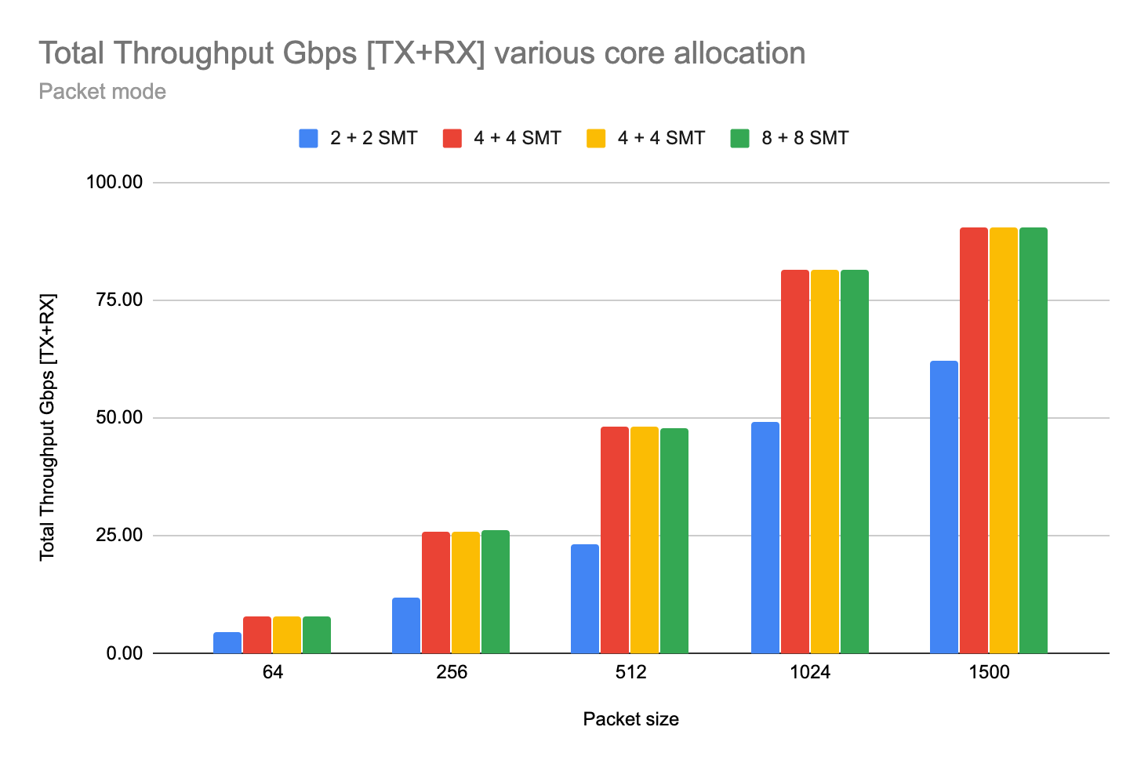

|  |  |  |  |  |  |
| --- | --- | --- | --- | --- | --- |
| CPU allocation | Packet Size [bytes] | | | | |
| 64 | 256 | 512 | 1024 | 1500 |
| 2 + 2 SMT | 4.49 | 11.80 | 23.10 | 49.32 | 62.10 |
| 4 + 4 SMT | 7.76 | 25.85 | 48.25 | 81.59 | **90.69** |
| 6 + 6 SMT | 6.84 | 20.31 | 38.82 | 67.95 | **87.28** |
| 8 + 8 SMT | 7.90 | 26.26 | 47.75 | 81.54 | **90.62** |

## Total Mpps [TX+RX] various core allocation

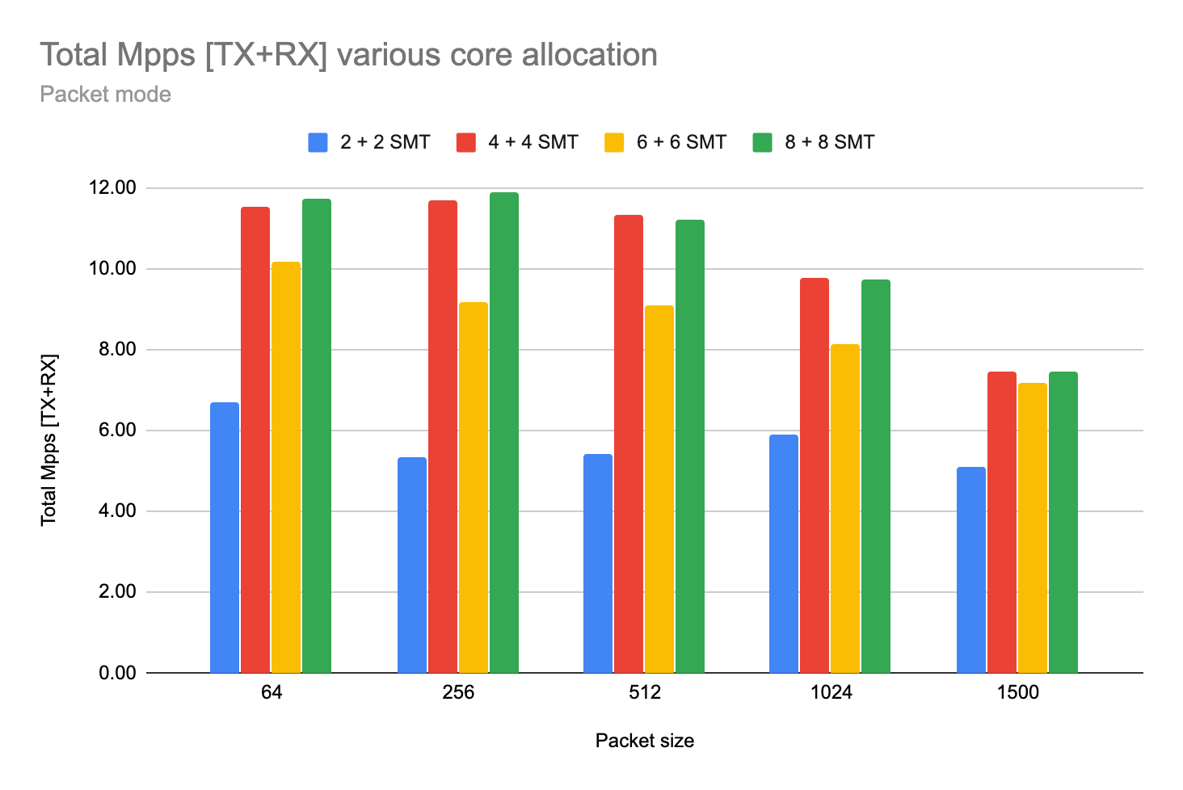

|  |  |  |  |  |  |
| --- | --- | --- | --- | --- | --- |
| CPU allocation | Packet Size [bytes] | | | | |
| 64 | 256 | 512 | 1024 | 1500 |
| 2 + 2 SMT | 6.68 | 5.35 | 5.43 | 5.90 | 5.11 |
| 4 + 4 SMT | 11.55 | 11.71 | 11.34 | 9.77 | 7.46 |
| 6 + 6 SMT | 10.17 | 9.20 | 9.12 | 8.14 | 7.18 |
| 8 + 8 SMT | **11.75** | **11.89** | 11.22 | 9.76 | 7.45 |

## 

## Mpps/core for 64B various core allocation

## 

## Chart

|  |  |
| --- | --- |
| CPU allocation | Packet Size [bytes] |
| 64 |
| 2 + 2 SMT | **3.34** |
| 4 + 4 SMT | 2.89 |
| 6 + 6 SMT | 1.70 |
| 8 + 8 SMT | 1.47 |

## 

## Average latency

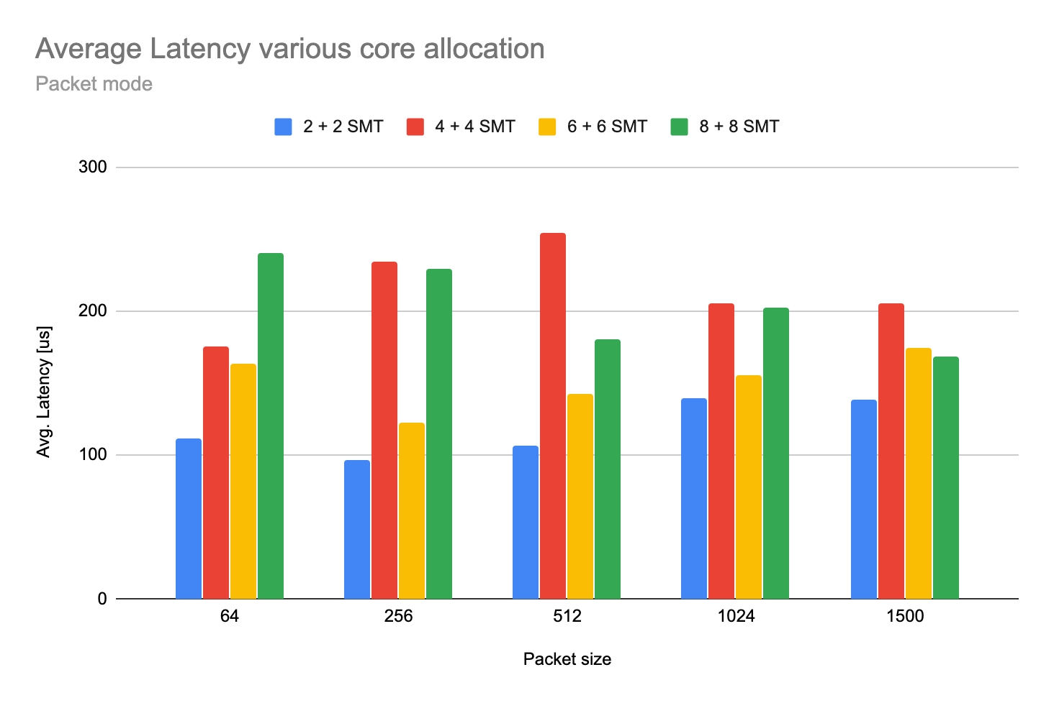

|  |  |  |  |  |  |
| --- | --- | --- | --- | --- | --- |
| CPU allocation | Packet Size [bytes] | | | | |
| 64 | 256 | 512 | 1024 | 1500 |
| 2 + 2 SMT | **112** | **97** | **107** | **140** | **139** |
| 4 + 4 SMT | 176 | 235 | 255 | 206 | 206 |
| 6 + 6 SMT | 164 | 123 | 143 | 156 | 175 |
| 8 + 8 SMT | 241 | 230 | 181 | 203 | 169 |

## 

## 

## Mellanox ConnectX-5 configuration

The NIC specific configuration parameters

|  |
| --- |
| lshw -c network -businfo| grep MT28800  pci@0000:a1:00.0 enp161s0f0 network MT28800 Family [ConnectX-5 Ex]  pci@0000:a1:00.1 enp161s0f1 network MT28800 Family [ConnectX-5 Ex]  cat /etc/sysconfig/network-scripts/ifcfg-vhost0  [...]  TYPE=dpdk  BIND_INT=0000:a1:00.0,0000:a1:00.1  BOND_MODE=4  BOND_POLICY=layer3+4  DRIVER=mlnx  CPU_LIST=32,33,34,35,36,37,38,39,160,161,162,163,164,165,166,167  NIC_OFFLOAD_ENABLE=False  LACP_RATE=1  SERVICE_CORE_MASK=40  DPDK_CTRL_THREAD_MASK=40  sed -e "s/\x00/ /g" /proc/$(pidof contrail-vrouter-dpdk)/cmdline  /usr/bin/contrail-vrouter-dpdk --no-daemon --vr_flow_entries=2000000 --vr_mempool_sz 2097136 --vr_dpdk_rx_ring_sz 4096 --vr_dpdk_tx_ring_sz 4096 --yield_option 0 --service_core_mask (40) --dpdk_ctrl_thread_mask (40) --socket-mem 1024 1024 --vdev eth_bond_bond1,mode=4,xmit_policy=l34,socket_id=0,mac=1c:34:da:65:82:c4,lacp_rate=1,slave=0000:a1:00.0,slave=0000:a1:00.1 |

## 

## Detailed data

|  |  |  |  |  |  |  |  |
| --- | --- | --- | --- | --- | --- | --- | --- |
| **vRouter Mode** | **Data** | **CPU** | **Packet size [bytes]** | | | | |
|  | **64** | **256** | **512** | **1024** | **1500** |
| Packet Mode | Total Throughput Gbps [TX+RX] | 2 + 2 SMT | 4.49 | 11.80 | 23.10 | 49.32 | 62.10 |
| 4 + 4 SMT | 7.76 | 25.85 | 48.25 | 81.59 | 90.69 |
| 6 + 6 SMT | 6.84 | 20.31 | 38.82 | 67.95 | 87.28 |
| 8 + 8 SMT | 7.90 | 26.26 | 47.75 | 81.54 | 90.62 |
| Throughput Gbps (Duplex) | 2 + 2 SMT | 2.25 | 5.90 | 11.55 | 24.66 | 31.05 |
| 4 + 4 SMT | 3.88 | 12.93 | 24.13 | 40.79 | 45.34 |
| 6 + 6 SMT | 3.42 | 10.16 | 19.41 | 33.98 | 43.64 |
| 8 + 8 SMT | 3.95 | 13.13 | 23.88 | 40.77 | 45.31 |
| Total Mpps [TX+RX] | 2 + 2 SMT | 6.68 | 5.35 | 5.43 | 5.90 | 5.11 |
| 4 + 4 SMT | 11.55 | 11.71 | 11.34 | 9.77 | 7.46 |
| 6 + 6 SMT | 10.17 | 9.20 | 9.12 | 8.14 | 7.18 |
| 8 + 8 SMT | 11.75 | 11.89 | 11.22 | 9.76 | 7.45 |
| Mpps/core | 2 + 2 SMT | 3.34 | 2.67 | 2.71 | 2.95 | 2.55 |
| 4 + 4 SMT | 2.89 | 2.93 | 2.83 | 2.44 | 1.86 |
| 6 + 6 SMT | 1.70 | 1.53 | 1.52 | 1.36 | 1.20 |
| 8 + 8 SMT | 1.47 | 1.49 | 1.40 | 1.22 | 0.93 |
| Avg. Latency | 2 + 2 SMT | 112 | 97 | 107 | 140 | 139 |
| 4 + 4 SMT | 176 | 235 | 255 | 206 | 206 |
| 6 + 6 SMT | 164 | 123 | 143 | 156 | 175 |
| 8 + 8 SMT | 241 | 230 | 181 | 203 | 169 |

# 

# Appendix

## Guide how to run testing framework

Deployment of Rapid on Contrail environment using publicly available repository of heat templates <https://github.com/damjanek/dpdk-prox-contrail> (simple version without ansible automation)

Deployment of Rapid on Contrail environment using Juniper internal repository of heat templates <https://ssd-git.juniper.net/sre/dpdk-testing> (advance version with ansible automation - optionally)

Rapid image gdrive (Juniper only) <https://drive.google.com/file/d/1bX6e7RdKzmay4yisaiqYcXT-a4B0EUCN/view?usp=sharing>

## Configure high performance Contrail Cloud computes

For compute nodes which will be acting as a traffic generator (gen VM) and looping (swap VM) please use the following template snippets.

site.yml

|  |
| --- |
| overcloud:  extra_config:  NovaSchedulerDefaultFilters:  - RetryFilter  - DifferentHostFilter  - SameHostFilter  - AvailabilityZoneFilter  - ComputeFilter  - ComputeCapabilitiesFilter  - ImagePropertiesFilter  - ServerGroupAntiAffinityFilter  - ServerGroupAffinityFilter  - NUMATopologyFilter  - AggregateInstanceExtraSpecsFilter  NovaComputeExtraConfig:  nova::cpu_allocation_ratio: 1.0  nova::ram_allocation_ratio: 1.0  nova::disk_allocation_ratio: 1.0  #  # node 0 cpus: 0 2 4 6 8 10 12 14 16 18 20 22 24 26  # 28 30 32 34 36 38 40 42 44 46 48 50 52 54  #  # node 1 cpus: 1 3 5 7 9 11 13 15 17 19 21 23 25 27  # 29 31 33 35 37 39 41 43 45 47 49 51 53 55  #  # OS: 0,1,28,29 (4 cores, including siblings)  # vRouter: 2,4,6,8,30,32,34,36  # Nova: rest of available cores from NUMA0 and optionally NUMA1  # Compute Node for Swap VM (min CPU 2+2HT good to have ability to increase during tests)  # Compute Node for the Generator (min CPU 4+4HT)    ComputeDpdkParameters:  TunedProfileName: "cpu-partitioning"  ContrailDpdkOptions: "--vr_flow_entries=2500000 --vr_mempool_sz 262144 --vr_dpdk_rx_ring_sz 2048 --vr_dpdk_tx_ring_sz 2048 --yield_option 0"  ContrailVrouterHugepages1GB: 220  ContrailVrouterHugepages2MB: 8192  IsolCpusList: "2-27,30-55"  KernelArgs: "isolcpus=2-27,30-55"  NovaVcpuPinSet: ['10','12','14','16','18','20','22','24','26','38','40','42','44','46','48','50','52','54']  nova::cpu_allocation_ratio: 1.0  nova::ram_allocation_ratio: 1.0  nova::disk_allocation_ratio: 1.0  ContrailSettings:  SERVICE_CORE_MASK: '0,1,28,29'  DPDK_CTRL_THREAD_MASK: '0,1,28,29'  LACP_RATE: 1 |

overcloud-nics.yml

|  |
| --- |
| # Compute Node for Swap VM (min CPU 2+2HT good to have possibility to increase during tests)  # Compute Node for the Generator (min CPU 4+4HT)  ComputeDpdk_network_config:  - type: interface  name: p1p1  dns_servers:  get_param: DnsServers  use_dhcp: false  mtu:  get_param: ControlPlaneNetworkMtu  addresses:  - ip_netmask:  list_join:  - '/'  - - get_param: ControlPlaneIp  - get_param: ControlPlaneSubnetCidr  routes:  -  ip_netmask: 169.254.169.254/32  next_hop:  get_param: EC2MetadataIp  -  default: True  next_hop:  get_param: ControlPlaneDefaultRoute  use_dhcp: false  - type: linux_bond  name: ten2  use_dhcp: false  bonding_options: "mode=802.3ad xmit_hash_policy=layer3+4 lacp_rate=fast updelay=1000 miimon=100"  mtu:  get_param: InternalApi1NetworkMtu  members:  - type: interface  name: em3  primary: true  mtu:  get_param: InternalApi1NetworkMtu  - type: interface  name: em4  mtu:  get_param: InternalApi1NetworkMtu  - type: vlan  device: ten2  vlan_id:  get_param: InternalApi1NetworkVlanID  mtu:  get_param: InternalApi1NetworkMtu  addresses:  - ip_netmask:  get_param: InternalApi1IpSubnet  routes:  -  ip_netmask:  get_param: InternalApiSupernet  next_hop:  get_param: InternalApi1InterfaceDefaultRoute  - type: vlan  device: ten2  vlan_id:  get_param: Storage1NetworkVlanID  mtu:  get_param: Storage1NetworkMtu  addresses:  - ip_netmask:  get_param: Storage1IpSubnet  routes:  -  ip_netmask:  get_param: StorageSupernet  next_hop:  get_param: Storage1InterfaceDefaultRoute  - type: contrail_vrouter_dpdk  name: vhost0  driver: "{{ overcloud['contrail']['vrouter']['dpdk']['driver'] }}"  bond_mode: 4  bond_policy: layer3+4  **cpu_list: "2,4,30,32"**  **# For the Generator set cpu_list: "2,4,6,8,30,32,34,36"**  members:  - type: interface  name: em1  - type: interface  name: em2  mtu:  get_param: Tenant1NetworkMtu  addresses:  - ip_netmask:  get_param: Tenant1IpSubnet  routes:  -  ip_netmask:  get_param: TenantSupernet  next_hop:  get_param: Tenant1InterfaceDefaultRoute |

## Configure high performance Contrail Networking on computes with TripleO heat templates

For compute nodes which will be acting as a traffic generator (gen VM) and looping (swap VM) please use the following template snippets.

environments/contrail/environment-extra.yaml

|  |
| --- |
| ComputeDpdk1Hw0Parameters:  ContrailDpdkOptions: --vr_flow_entries=2500000 --vr_mempool_sz 262144 --vr_dpdk_rx_ring_sz 2048 --vr_dpdk_tx_ring_sz 2048 --yield_option 0  ContrailSettings:  DPDK_CTRL_THREAD_MASK: '0,1,28,29'  LACP_RATE: 1  SERVICE_CORE_MASK: '0,1,28,29'  ContrailVrouterHugepages1GB: 220  ContrailVrouterHugepages2MB: 8192  IsolCpusList: 2-27,30-55  KernelArgs: isolcpus=2-27,30-55  NovaVcpuPinSet:  - '10'  - '12'  - '14'  - '16'  - '18'  - '20'  - '22'  - '24'  - '26'  - '38'  - '40'  - '42'  - '44'  - '46'  - '48'  - '50'  - '52'  - '54'  TunedProfileName: cpu-partitioning  nova::cpu_allocation_ratio: 1.0  nova::disk_allocation_ratio: 1.0  nova::ram_allocation_ratio: 1.0 |

overcloud-nics.yml

|  |
| --- |
| # Compute Node for Swap VM (min CPU 2+2HT good to have possibility to increase during tests)  # Compute Node for the Generator (min CPU 4+4HT)  ComputeDpdk_network_config:  - type: interface  name: p1p1  dns_servers:  get_param: DnsServers  use_dhcp: false  mtu:  get_param: ControlPlaneNetworkMtu  addresses:  - ip_netmask:  list_join:  - '/'  - - get_param: ControlPlaneIp  - get_param: ControlPlaneSubnetCidr  routes:  -  ip_netmask: 169.254.169.254/32  next_hop:  get_param: EC2MetadataIp  -  default: True  next_hop:  get_param: ControlPlaneDefaultRoute  use_dhcp: false  - type: linux_bond  name: ten2  use_dhcp: false  bonding_options: "mode=802.3ad xmit_hash_policy=layer3+4 lacp_rate=fast updelay=1000 miimon=100"  mtu:  get_param: InternalApi1NetworkMtu  members:  - type: interface  name: em3  primary: true  mtu:  get_param: InternalApi1NetworkMtu  - type: interface  name: em4  mtu:  get_param: InternalApi1NetworkMtu  - type: vlan  device: ten2  vlan_id:  get_param: InternalApi1NetworkVlanID  mtu:  get_param: InternalApi1NetworkMtu  addresses:  - ip_netmask:  get_param: InternalApi1IpSubnet  routes:  -  ip_netmask:  get_param: InternalApiSupernet  next_hop:  get_param: InternalApi1InterfaceDefaultRoute  - type: vlan  device: ten2  vlan_id:  get_param: Storage1NetworkVlanID  mtu:  get_param: Storage1NetworkMtu  addresses:  - ip_netmask:  get_param: Storage1IpSubnet  routes:  -  ip_netmask:  get_param: StorageSupernet  next_hop:  get_param: Storage1InterfaceDefaultRoute  - type: contrail_vrouter_dpdk  name: vhost0  driver: "{{ overcloud['contrail']['vrouter']['dpdk']['driver'] }}"  bond_mode: 4  bond_policy: layer3+4  **cpu_list: "2,4,30,32"**  **# For the Generator set cpu_list: "2,4,6,8,30,32,34,36"**  members:  - type: interface  name: em1  - type: interface  name: em2  mtu:  get_param: Tenant1NetworkMtu  addresses:  - ip_netmask:  get_param: Tenant1IpSubnet  routes:  -  ip_netmask:  get_param: TenantSupernet  next_hop:  get_param: Tenant1InterfaceDefaultRoute |

# 

# 

# References

Rapid wiki <https://wiki.opnfv.org/display/SAM/Rapid+scripting>